**National University of Computer & Emerging Sciences, Karachi**

**School of Computing Department**

**Spring 2023, Lab Manual – 07 Task**

|  |  |
| --- | --- |
| **Course Code: CL-2005** | **Course : Database Systems Lab** |
| **Instructor(s) :** | **Noureen Fatima** |

**Task-01**

Consider a  [NCRA-NATIONAL CENTER OF ROBOTICS & AUTOMATION Camera-Ready Paper Submission System](https://ncai.smme.nust.edu.pk/)

CONFERENCE_REVIEW database in which researchers submit their research papers for consideration. Reviews by reviewers are recorded for use in the paper selection process. The database system caters primarily to reviewers who record answers to evaluation questions for each paper they review and make recommendations regarding whether to accept or reject the paper. The data requirements are summarized as follows:

* Authors of papers are uniquely identified by e-mail id. First and last names are also recorded.
* Each paper is assigned a unique identifier by the system and is described by a title, abstract, and the name of the electronic file containing the paper.
* A paper may have multiple authors, but one of the authors is designated as the contact author.
* Reviewers of papers are uniquely identified by e-mail address. Each reviewer’s first name, last name, phone number, affiliation, and topics of interest are also recorded.
* Each paper is assigned between two and four reviewers. A reviewer rates each paper assigned to him or her on a scale of 1 to 10 in four categories: technical merit, readability, originality, and relevance to the conference. Finally, each reviewer provides an overall recommendation regarding each paper.
* Each review contains two types of written comments: one to be seen by the review committee only and the other as feedback to the author(s).

1. **Develop the Logical Model Diagram for the CONFERENCE_REVIEW database and build the design using a data modeling tool data modeler**
2. **Develop the Relational Model Diagram for the CONFERENCE_REVIEW database and build the design using a data modeling tool data modeler**
3. **Generate DDL**

**Task-02**

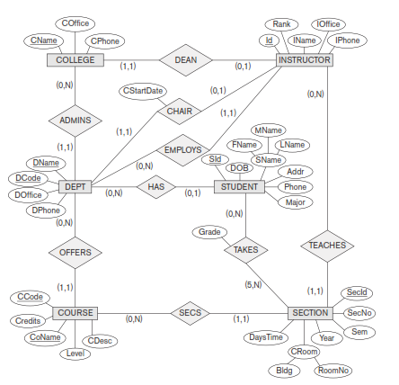

1. **Consider the ER diagram for the AIRLINE database shown in Figure above and Develop the Logical Model using a data modeling tool data modeler**
2. **Consider the ER diagram for the AIRLINE database shown in Figure above and Develop the Relational Model using a data modeling tool data modeler**
3. **Generate DDL**

**Task-03**

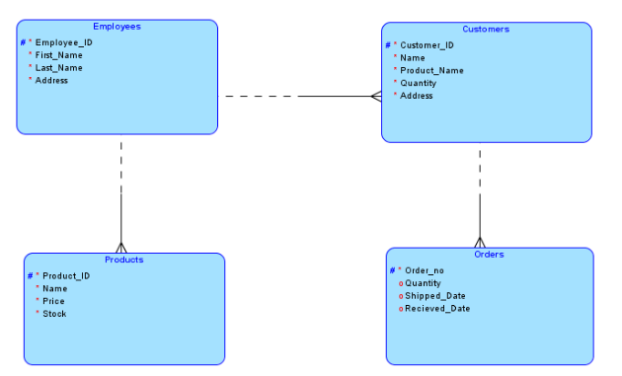

* Create a physical design (DDL) from the above logically designed database.
* Keeping in mind the logical design, create foreign keys in each table where required.
* Populate each table up to maximum three records.